+01002-The World of the Harp (Marisa Robles)

專輯英文名：The World of the Harp (Marisa Robles)
專輯中文名：豎琴的音樂世界
演奏家：Marisa Robles, harp瑪麗莎．羅培士
古典類型：Modern, Romantic, Classical室內樂
發行公司：Decca
發行時間：1992年
唱片編號：433 869-4
地區：英國
資源格式：APE
簡介：

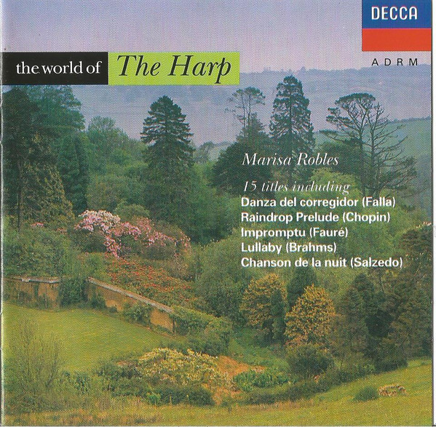

專輯介紹：

Marisa Robles
From Wikipedia, the free encyclopedia

Marisa Robles (born May 4, 1937) is a Spanish harpist and composer.
She was born in Spain, where she studied the harp with Luisa Menarguez, and studied music at the Madrid Conservatory, graduating at the age of sixteen in 1953. She made her concert debut at seventeen, performing with flautist Jean-Pierre Rampal.
The Concerto for Flute and Harp by Mozart which they performed together was to become the piece for which she is best known. She has recorded and performed it with James Galway and with her husband Christopher Hyde-Smith, among others. In 1963 she premiered Sones en la Giralda on the BBC, a wedding present written for her by Joaquín Rodrigo. In 1981, she wrote the music for a set of audiobooks of the Chronicles of Narnia, narrated by Sir Michael Hordern. This was released as her Narnia Suite in 1981, with Robles playing harp and her husband the flute.
In 1958 she married, and in 1960 she came to live permanently in the UK. In 1971 she became a professor of harp in the Royal College of Music. She now has three children, St. John Harvey, Grania Hyde-Smith and Alexander Hyde-Smith.
Robles was artistic director for the first two Cardiff World Harp Festivals in 1991 and 1994.
瑪麗莎·羅伯斯（Marisa Robles，1937年5月4日出生）是一位西班牙豎琴家和作曲家。
她出生於西班牙，在那裡跟隨Luisa Menarguez學習豎琴，並在馬德里音樂學院學習音樂，1953年16歲時畢業。17歲時，她首次舉辦音樂會，與長笛演奏家Jean-Pierre Rampal合作。他們一起演奏的莫扎特長笛與豎琴協奏曲成為她最著名的作品。她與詹姆斯·哥爾韋和她的丈夫克里斯多夫·海德·史密斯等人一起錄製並表演了這首歌曲。1963年，她在BBC上首演了華金·羅德里戈(Joaquín Rodrigo)為她寫的結婚禮物《Sones en la Giralda》。1981年，她為一套《納尼亞傳奇》有聲讀物創作了音樂，由邁克爾·霍登爵士擔任旁白。1981年，這首曲子作為她的納尼亞組曲發行，羅伯斯演奏豎琴，她的丈夫演奏長笛。
1958年，她結婚，並於1960年在英國永久居住。1971年，她成為皇家音樂學院的豎琴教授。她現在有三個孩子：聖約翰·哈威、格拉尼亞·海德·史密斯和亞歷山大·海德·史密斯。羅伯斯在1991年和1994年擔任前兩屆卡迪夫世界豎琴節的藝術總監。
**********************************************************************************

Marisa Robles Biography by Patsy Morita
Marisa Robles studied harp as a child with Luisa Menarguez, made her debut at age nine, and went on to graduate from the Madrid Conservatory in 1953 at the age of 16. The next year, she made her concert debut in Madrid, performing with Jean-Pierre Rampal in Mozart's Concerto for flute and harp, K. 299. The work would become her signature piece; she recorded it four times with James Galway and has performed it in concert more than 1,000 times over the course of her career. Her time teaching at the Madrid Conservatory was brief: after joining the staff in 1958, she married and moved to England in 1959, eventually taking British citizenship. In England, Robles became known for television appearances, whereby she introduced harp music to new audiences. Between 1971 and 1993 she taught at the Royal College of Music, but also spent much time touring and performing around the world, including a 1988 trip to China. She has worked with such conductors as Zubin Mehta, Kurt Masur, Rafael Frühbeck de Burgos, Mstislav Rostropovich, and Yehudi Menuhin. She also frequently performed chamber music, especially with her second husband, flutist Christopher Hyde-Smith. Her amiable stage personality and her warm, clear playing endeared her not only to audiences, both live and television, but also to composers. Among those who dedicated harp concertos to her were Manuel Moreno-Buendia, who wrote a concerto for her in 1958 and a second one for harp, marimba, and strings for her in 1994; Joaquín Rodrigo (Sones en la Giralda, 1963); Malcolm Williamson; Jesús Guridi; and John Metcalf. She has also been the dedicatee of chamber works by William Mathias, Stephen Dodgson, Alun Hoddinott, and William Alwyn. Robles was artistic director for the first two Cardiff World Harp Festivals in 1991 and 1994. Around the same time, she appeared in the Emmy-winning television series Concerto! with Galway and Michael Tilson Thomas, again performing the Mozart. In addition to her recordings of Mozart, she has recorded the music of Debussy and Rodrigo, an album of popular harp solos, and music by Edwin Robertson based on C.S. Lewis' Chronicles of Narnia with both Hyde-Smith and her own harp ensemble.
瑪麗莎·羅伯斯(Marisa Robles)從小跟隨路易莎·梅納爾格斯(Luisa Menarguez)學習豎琴，9歲時首次亮相，1953年16歲時從馬德里音樂學院畢業。次年，她在馬德里首次舉辦音樂會，與讓-皮埃爾·拉姆帕爾 (Jean-Pierre Rampal)合作演奏的莫札特長笛與豎琴協奏曲，K. 299。這部作品後來成為她的標誌性作品；她與詹姆斯·哥爾韋(James Galway)錄製了四次這首歌曲，並在她的職業生涯中在音樂會上演奏1,000多次。
她在馬德里音樂學院任教的時間很短：1958年加入音樂學院後，她結婚並於1959年搬到英國，最終獲得了英國公民身份。在英國，羅伯斯因在電視上露面而聞名，她向新觀眾介紹了豎琴音樂。1971年至1993年間，她在皇家音樂學院任教，但也花了很多時間在世界各地巡演和表演，包括1988年的中國之行。
她曾與祖賓·梅塔、庫爾特·馬蘇爾、拉斐爾·弗魯貝克·德·布林戈斯、姆斯蒂斯拉夫·羅斯特羅波維奇和耶胡迪·梅紐因等指揮家合作過。她還經常演奏室內樂，特別是與她的第二任丈夫、長笛演奏家克里斯多夫·海德·史密斯一起演奏。她和藹可親的舞臺個性和溫暖、清晰的演奏不僅贏得了現場和電視觀眾的喜愛，也贏得了作曲家的喜愛。
曼努埃爾·莫雷諾-布恩迪亞(Manuel Moreno-Buendia)為她創作了豎琴協奏曲，他於1958年為她創作了一首協奏曲，並於1994年為她創作了第二部豎琴、馬林巴和絃樂協奏曲。華金·羅德里戈(Joaquín Rodrigo)(《Sones en la Giralda》，1963)；瑪律科姆·威廉姆森；耶穌·古裡迪；和約翰·梅特卡夫。她還致力於威廉·馬蒂亞斯、斯蒂芬·道奇森、阿倫·霍迪諾特和威廉·阿爾文的室內樂作品。
羅伯斯在1991年和1994年擔任前兩屆卡迪夫世界豎琴節的藝術總監。大約在同一時間，她出現在榮獲艾美獎的電視連續劇協奏曲中！與哥爾韋和邁克爾·蒂爾森·湯瑪斯再次演奏莫札特。除了莫札特的唱片外，她還與海德·史密斯和她自己的豎琴合奏團錄製了德彪西和羅德里戈的音樂、流行豎琴獨奏專輯以及愛德溫·羅伯遜根據C.S.路易斯的《納尼亞傳奇》創作的音樂。
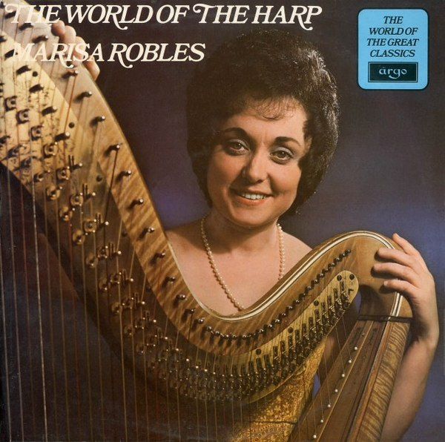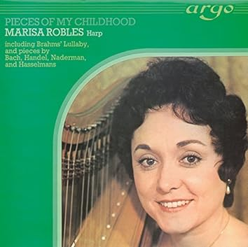

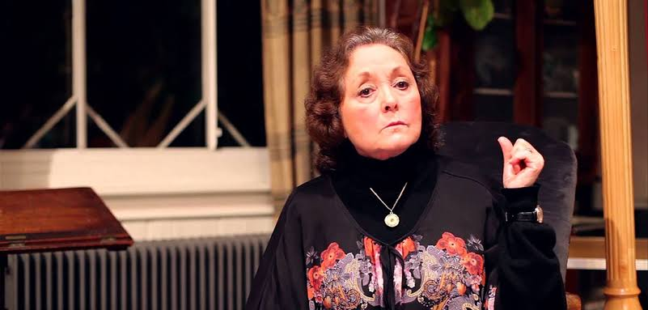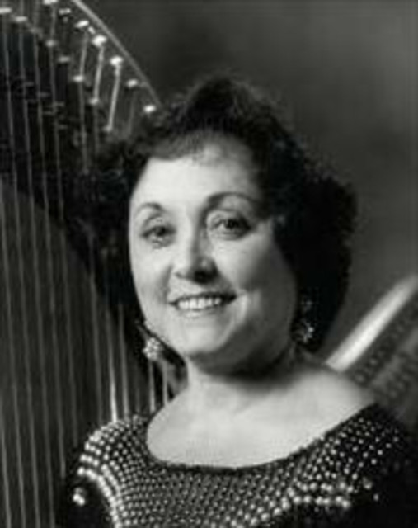
*************************************************************************************

音響二十要之“解析力”
入選原因：Marisa Robles是非常有名的豎琴演奏家，她在Decca錄製了很多的豎琴音樂，她的琴藝無疑是入選原因之一。不過，她的琴藝與測試低頻的解析力並沒有關係，與它有關係的是在錄音時穿過Kingsway Hall的地鐵噪音，那才是測試低頻解析力的主角。假若您的低頻解析力越好，您在第七軌所聽到的地鐵聲音也就越逼真。當然，您在測試過低頻解析力之後，可以輕鬆的躺下來好好享受一下豎琴甜美的聲音。
難關：您在聽第七軌時只是聽到呼呼的模糊低頻噪音嗎？請移動喇叭位置再聽。您聽出那呼呼的低頻噪音是錄音室外汽車噪音嗎？還是不正確，不過已經有進步。請再調整聆聽位置與喇叭位置。您已經可以聽出那呼呼聲像是地鐵跑在鐵軌上的聲音了嗎？恭喜您，越來越接近了。不僅可以聽出火車跑在軌道上的噪音，也可以清楚辨別火車行駛的方向。這個時候又更上一層樓了。最後，您可以清楚的聽到那低頻噪音在圓拱形隧道內回蕩的空間感嗎？此時您大功告成矣。

專輯曲目：
01. Manuel de Falla (1876-1946) - Danza del Corregidor州長之舞 3:13 3:03
Recorded: Decca Studios, West Hampstead, London in 1965-10
02. Isaac Albéniz (1860-1909) (arr. Ginebra Bruno) - Rumores de la Caleta 4:00 7:06
Recorded: Decca Studios, West Hampstead, London in 1965-10
03. Isaac Albéniz (1860-1909) (arr. Ginebra Bruno) - Torre Bermeja 4:48 11:54
Recorded: Decca Studios, West Hampstead, London in 1965-10
04. Jesus Guridi Bidaola (1886-1961) - Viejo Zortzico 5:44 17:38
Recorded: Decca Studios, West Hampstead, London in 1965-10
05. Anton Eberl (1765-1807) - Theme of Mozart, Variations and Rondo
Pastorale 11:02 28:39
Recorded: Decca Studios, West Hampstead, London in 1967-05
06. Ludwig van Beethoven (1770-1827) - Variations on a Swiss Song 5:17 33:56
Recorded: Decca Studios, West Hampstead, London in 1967-05
07. Benjamin Britten (1913-1976) - Ceremony of Carols, Op.28, Interlude * 4:06 38:09
Recorded: St. John's College, Cambridge in 1966-08-08 (有地鐵車聲)
08. Gabriel Faure (1845-1924) - Impromptu, Op.86 9:01 47:06
Recorded: Decca Studios, West Hampstead, London in 1965-12
09. Gabriel Pierne (1863-1937) - Impromptu-Caprice, Op.9 5:52 52:57
Recorded: Decca Studios, West Hampstead, London in 1965-12
10. Carlos Salzedo (1885-1961) - Chanson de la Nuit 3:51 56:50
Recorded: Decca Studios, West Hampstead, London in 1965-12
11. Johannes Brahms (1833-1897) (arr. Robles) - Lullaby 2:42 59:31
Recorded: St. George The Martyr, London in 1978-06-02
12. Johann Sebastian Bach (1685-1750)- Prelude No.1 3:23 62:56
Recorded: St. George The Martyr, London in 1978-06-02
13. Frederic Chopin (1810-1849) - Mazurka, Op.7 No.1 3:03 66:02
Recorded: St. George The Martyr, London in 1981-02
14. Frederic Chopin (1810-1849) - 24 Préludes, Op. 28 No.15 in D flat,
- "Raindrop" 6:01 72:01
Recorded: St. George The Martyr, London in 1981-02
15. Alphonse Hasselmans (1845-1912) - Concert Study 'La Source' 3:15 75:27
Recorded: St. George The Martyr, London in 1978-06-02

